**DR. D Y PATIL INTERNATIONAL UNIVERSITY**

**DSP LAB – 10**

**NAME : Chris Parmar**

**PRN : 20220802034**

**BATCH : A1**

1. **HIGH PASS – FIR FILTER**

% Simple FIR Filter Design using Window Method (Lowpass or Highpass)

clc;

clear;

% Step 2: Enter filter specifications

Fs = 1000; % Sampling frequency in Hz

Wp = 200; % Passband frequency in Hz

Ws = 300; % Stopband frequency in Hz

N = 20; % Filter order

% Choose filter type: 'lowpass' or 'highpass'

filterType = 'highpass'; % 'lowpass' or 'highpass'

% Step 4: Design the filter

if strcmp(filterType, 'lowpass')

b = fir1(N, Wp / (Fs / 2), 'low', hamming(N+1)); % Low-pass filter

elseif strcmp(filterType, 'highpass')

b = fir1(N, Wp / (Fs / 2), 'high', hamming(N+1)); % High-pass filter

end

% Step 5: Frequency Response

[H, F] = freqz(b, 1, 512, Fs);

% Step 6: Plot magnitude and phase

subplot(2, 1, 1);

plot(F, abs(H)); % Magnitude plot

title('Magnitude Response');

xlabel('Frequency (Hz)');

ylabel('Gain (dB)');

subplot(2, 1, 2);

plot(F, angle(H)); % Phase plot

title('High Pass Phase Response');

xlabel('Frequency (Hz)');

ylabel('Angle');

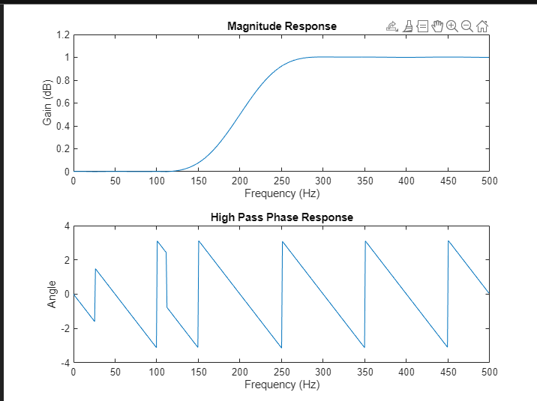

1. **LOW PASS – FIR FILTER**

% Simple FIR Filter Design using Window Method (Lowpass or Highpass)

clc;

clear;

% Step 2: Enter filter specifications

Fs = 1000; % Sampling frequency in Hz

Wp = 200; % Passband frequency in Hz

Ws = 300; % Stopband frequency in Hz

N = 20; % Filter order

% Choose filter type: 'lowpass' or 'highpass'

filterType = 'lowpass'; % 'lowpass' or 'highpass'

% Step 4: Design the filter

if strcmp(filterType, 'lowpass')

b = fir1(N, Wp / (Fs / 2), 'low', hamming(N+1)); % Low-pass filter

elseif strcmp(filterType, 'highpass')

b = fir1(N, Wp / (Fs / 2), 'high', hamming(N+1)); % High-pass filter

end

% Step 5: Frequency Response

[H, F] = freqz(b, 1, 512, Fs);

% Step 6: Plot magnitude and phase

subplot(2, 1, 1);

plot(F, abs(H)); % Magnitude plot

title('Magnitude Response');

xlabel('Frequency (Hz)');

ylabel('Gain (dB)');

subplot(2, 1, 2);

plot(F, angle(H)); % Phase plot

title('Low Pass Phase Response');

xlabel('Frequency (Hz)');

ylabel('Angle');

